ASSIGNMENT 49

Name : Akanksha Joshi

Roll No : B038

Batch : 3

Div : BTech CS B

-------------------------------------------------------------------------------------------------------------------------------

Source Code

List

sample_list=[35,25,69,78,45,36,21,89]

print(sorted(sample_list))

print(sample_list)

Tuple:

student_tuple = ('ishi','Sam','Jd')

print(sorted(student_tuple,reverse = True))

print(student_tuple)

Dictionary:

student_dict ={105:'Jay',103:'Kayan',104:'Satya',102:'Jaydeep'}

print(sorted(student_dict))

print(student_dict)

Output

List



Tuple

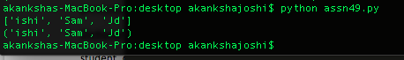

Dictionary

